1. When I decrease the value of n_colors it reduces the colors for the image.
2. This can be mainly useful in object recognition.
3. When I decreased the value of n_colors then it completely reduced the color of the image. Yes It looked funny at the end as I used my fiancé image so it made me to laugh after seeing the colors of the image.
4. C) After running for 1000 samples the results are like

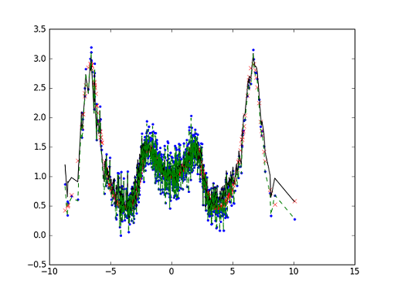

While increasing the number I have seen that the simultaneously the accuracy also increased.

For N=1000 I got 95 neurons and the eta is 1.0

e) After running the program for 10000 samples the difference I have observed is:

When increasing the number at certain point I was expecting the accurate result compare to the previous experiment.

Here in this experiment also the eta is same 1.0 but the number of neurons I got is different

For N=10000 eta is 1.0.

